**SHRI GURU SANDIPANI INSTITUTE OF TECHNOLOGY & SCIENCE**

**UJJAIN (M.P)**

TITLE OF PROJECT

**Students Performance Indicators**



A Dissertation submitted in partial fulfillment

For the requirement for the degree of

### BACHELOR OF TECHONOLOGY IN

**COMPUTER SCIENCE AND ENGINEERING**

### Under the guidance of

### Prof. Jyoti Chouhan

**Submitted too: Submitted by:**

**Prof.** Jyoti Chouhan **Vishal Chouhan (0722CS201064)**

**Raj Lodhi (0722CS201051)**

**Devendra Singh Pipawad**

**(0722CS201012)**

**CANDIDATE’S DECLARATION**

I hereby certify that the project entitled **“ Students performance indicators ”**  submitted by Vishal Chouhan(0722CS201064) , Devendra singh pipawad (0722CS201012) , Raj lodhi (0722CS201011) in partial fulfillment of the requirement for the award of degree of the B. Tech. (Computer Science & Engineering) submitted in Rajiv Gandhi Proudyogiki Vishwavidyalaya Technological University, at Shri Guru Sandipani Institute of Technology & Science Ujjain(M.P), 2023 to September to December, 2023 under the guidance of Prof. Jyoti Chouhan (Deaprtment of Computer Science & Engineering). The matter presented in this project has not formed the basis for the award of any other degree, diploma, fellowship or any other similar titles.

Signature of the Student

### Place: Ujjain

### Date:

### 

**Ref. No. ................................. Date .....................**

# **CERTIFICATE**

This is to certify that the project titled **“ Students Perfomance indicators ”**  is the bona fide work carried out by Vishal Chouhan(0722CS201064) , Devendra singh pipawad (0722CS201012), Raj lodhi (0722CS201011) in partial fulfillment of the requirement for the award of degree of the B. Tech. (Computer Science & Engineering) submitted in Rajiv Gandhi Proudyogiki Vishwavidyalaya Technological University, at Shri Guru Sandipani Institute of Technology & Science Ujjain (M.P) 2023 to September to December, 2023 under the guidance of ProfJyoti Chouhan (Deaprtment of Computer Science & Engineering). The Major Project Viva-Voce Examination has been held on (DD/MM/YYYY)

### Sign. of the Guide Sign. of the HOD, of CSE

**Prof:** Jyoti Chouhan

**Signature of the Principal SGSITS Ujjain**

### Shri Guru Sandipani Institute of Technology & Science Ujjain

### Ph. 07368-261336

**Website:**  [**http://sgsitsujjain.in/**](%20http://sgsitsujjain.in/) **Email:** [sgsitsenquiry@gmail.com](mailto:sgsitsenquiry@gmail.com)

**ACKNOWLEDGEMENT**

The best we have gained while working in this project was to be efficient and clean in our work. Any work pays you good when planned and undertaken in an organized way. The best way to proceed is to have good ideas and a lot of ideas, always remembering that there exist many a ways to tackle a given problem. Also if it is important to have ideas it is more important to implement them, and the project that you are holding is a result of such an idea.

This work is the result of inspiration, support, guidance, cooperation and facilities that were extended to us at their best and at the most by persons at all labels and we are indebted to all of them.

We express deep sense of gratitude and indebtedness to our respected **Prof.** **Jyoti Chouhan** for their valuable, affectionate guidance and constructive criticism at all stages of our project work.

We would further like to thanks all other members of personnel department who were always there with guidance and suggestions. This acknowledgement can never be complete without thanking **Prof. Sandeep Joshi HOD Computer Science & Engineering Department** who helps us during our project work.

At last we would like to thank all those who helped us directly or indirectly during the course of present work.

**Name:**

Vishal chouhan (0722CS201064)

Devendra Singh Pipawad(0722CS201012)

Raj lodhi(0722CS201051)

**DISSERTATION APPROVAL SHEET**

This is to certify that the dissertation entitled **“SUPER PIRATE”** submitted by**, Vishal Chouhan(0722CS201064), Devendra singh pipawad (0722CS201012), Raj lodhi (0722CS201011)** to Shri Guru Sandipani Institute of Technology & Science Ujjain (M.P) is approved as partial fulfillment of the requirement for the award of the degree of Bachelor of Technology (Computer Science) (VI Semester) by SGSITS Ujjain (M.P).

**Internal Examiner: External Examiner:**

……………………. ……………………..

**Principal, SGSITS**

**Ujjain (M.P)**

**INDEX PAGE**

**Abstract 1**

**1.Introduction………………………. 2**

**2.Problem domain………………….. 3**

i. Variable…………………….

ii. Target variable……………..

**3. Solution domain………………… 4**

i. Data loading and cleaning………

ii. Exploratory data analysis………

iii. Machine learning model………

**4. System domain……………….… 5**

i. Python programming language..

ii. Data science library…………….

iii. Data analysis and modeling environment……….

iv. Data preprocessing ………….

v. Future engineering…………...

vi. Model training………………

vii. Model evolution……………

viii. Model deployment………...

**5. Application domain……………… 6**

**6. Expected outcome…………………………….. 7**

**7. List of Figure………………………………….. 8**

**8.Use case diagram………………………………. 9**

**9. Activity diagram………………………………. 10**

**10. Sequence diagram……………………………. 11**

**11.Data model…………………………………….. 12**

i. Data flow diagram…………………. 12

ii. ER diagram…………………………. 13

**12.Future scope……………………………… 14**

i. Educational institutions………

ii.Teacher effectiveness……

iii.Parents………………….

iv.Student…………………

**8.** **Conclusion……………………………….. 15**

# **ABSTRACT**

This project aims to explore and analyze student performance data using Python programming language and data science techniques machine learning techniques. The project will focus on identifying factors that influence student performance, developing predictive models to forecast student outcomes, and providing insights to educational institutions for improving student success rates. The project will focus on exploratory data analysis, feature engineering, and machine learning algorithms to uncover patterns and insights from the data. The insights gained will be used to inform educational interventions and improve student outcomes.

1. **INTRODUCTION**

In this project, the performance of the students will be predicted so that their performance can be easily ascertained. And they will also know the reasons due to which their performance is decreasing. Performance indicators reflect what concrete tasks the student should be able to perform as a result of participation in the program. Once the program outcomes have been identified, the knowledge and skills required to master these outcomes should be listed. This will help in improving the desired behavior of the students and their performance. The field of education is increasingly recognizing the importance of data-driven decision-making to enhance student learning and achievement. By analyzing student performance data, educators and student can gain valuable insights into factors that contribute to success or failure, enabling them to tailor teaching strategies and interventions accordingly. The importance of understanding and analyzing student performance cannot be overstated. By evaluating student performance indicators, educational institutions can gain valuable insights into the factors that contribute to student success and identify areas for improvement. This information can be used to implement targeted interventions, refine teaching strategies, and ultimately enhance the overall learning experience for all students.

1. **PROBLEM DOMAIN**

The problem domain of this project is student performance analysis and prediction. The challenge lies in identifying the key factors that affect student performance and developing a model that can accurately predict student outcomes. This requires a comprehensive understanding of educational data and the ability to apply data science techniques to extract meaningful patterns and insights. Or Predicting student performance poses a significant challenge due to the complex interplay of various factors, including academic background, socioeconomic status, motivation, and individual learning styles. Traditional methods for predicting student performance often rely on limited data and fail to capture the nuances of individual student characteristics. Machine learning offers a more sophisticated approach by utilizing larger datasets and identifying complex patterns that may not be readily apparent through traditional analysis methods. This project understands how the student's performance (test scores) is affected by other variables such as Gender, Ethnicity, Parental level of education, Lunch and Test preparation course.

**Variable:**

* **gender**: Sex of a student. (Male/Female)
* **race/ethnicity**: Ethnicity of a student.
* **parental level of education**: parents' final education. (bachelor's degree, some college, master's degree, associate's degree, high school)
* **Lunch**: What type of lunch the student had before test.
* **Test preparation course**: Whether the student completed any preparation course before the test.
* **Reading score**: Reading score obtained by the student.
* **Writing score**: Writing score obtained by the student.

**Target variable:**

* **Math score**: Math score of a student.

1. **SOLUTION DOMAIN**

The solution domain of this project involves utilizing Python programming language and data science libraries to address the aforementioned challenges. The project will employ the following techniques:

* **Data Loading and Cleaning:** Using Python libraries like Pandas to load, clean, and manipulate student performance data.
* **Exploratory Data Analysis:** Applying data visualization techniques using Matplotlib and Seaborn to explore data distributions, identify trends, and visualize relationships between variables.
* **Machine Learning Modeling:** Employing machine learning algorithms like linear regression and classification models to predict student performance and identify factors influencing academic success.

1. **SYSTEM DOMIAN**

The machine learning system for predicting student performance and the system domain the software tools and technologies used to implement the data analysis and modeling tasks. The project will utilize consists of several components:

* **Python Programming Language:** Python will serve as the primary programming language for data manipulation, analysis, and modeling.
* **Data Science Libraries:** Libraries like Pandas, Numpy, Matplotlib, Seaborn, and scikit-learn will provide essential tools for data exploration, visualization, and machine learning.
* **Data Analysis and Modeling Environment:** Jupyter Notebook will be used as an interactive environment for data analysis, model development, and visualization.
* **Data Preprocessing:** Cleaning, transforming, and normalizing the educational data to ensure its suitability for machine learning algorithms.
* **Feature Engineering:** Extracting relevant features from the data and encoding them appropriately for machine learning algorithms.
* **Model Training:** Selecting and training machine learning models to predict student performance, such as regression models for continuous outcomes and classification models for categorical outcomes.
* **Model Evaluation:** Evaluating the performance of trained models using metrics such as accuracy, precision, and recall.
* **Model Deployment:** Integrating the trained models into educational systems to provide real-time predictions and support decision-making.

1. **APPLICATION DOMIAN**

The findings of this project can be applied to various educational settings, including primary and secondary schools, higher education institutions, universities and online learning platforms. The project can provide valuable insights for educators to identify at-risk students and implement targeted interventions to improve their academic performance.

1. **EXPECTED OUTCOMES**

* Develop predictive models capable of forecasting student performance.
* Identify key factors influencing academic success.
* Provide insights for educators to improve student learning outcomes.
* Develop a framework for implementing machine learning techniques in educational data analysis.

**List of Figure:-**

1. Use Case
2. Activity Diagram
3. Sequence Diagram
4. Data Model

• Data Flow Diagram

• ER Diagram

1. **Use case diagram :-**

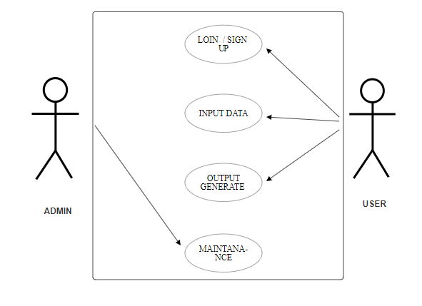

1. **Activity Diagram :-**

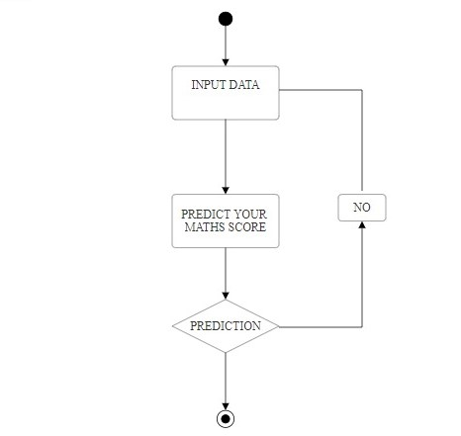

1. **Sequence Diagram :-**

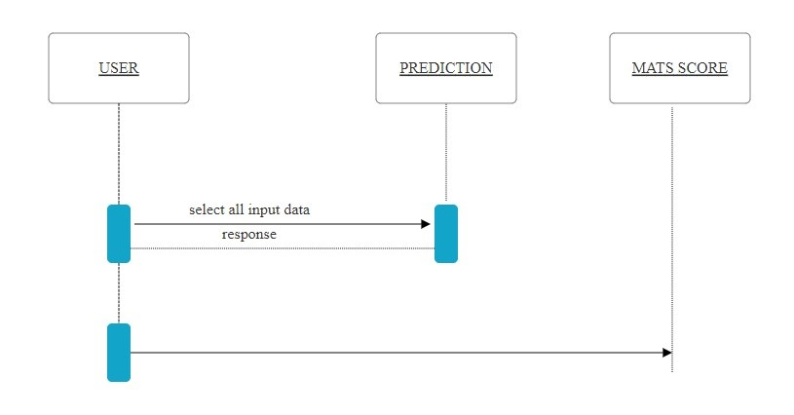

1. **Data Model :-**

• Data Flow Diagram

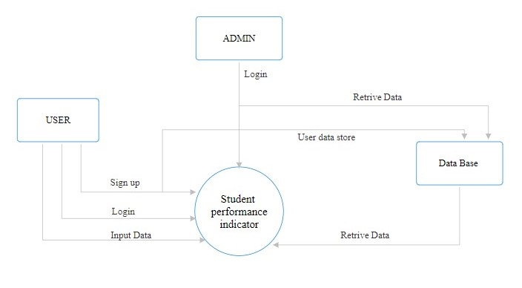

• **ER Diagram**

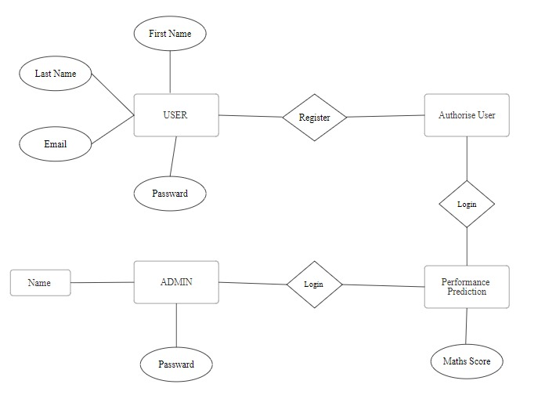

1. **FUTURE SCOPE:**

The future scope of student performance indicators projects is bright and promising. As the demand for data-driven decision-making in education continues to grow, Student performance indicators project will play an increasingly important role in helping educators improve student outcomes.

Here are some specific areas where Student performance indicators project are likely to have a significant impact in the future:

* **Educational institutions:** In educational institutions like primary and secondary schools, higher education institutions, universities and online learning platforms. Student performance indicators project can be used to identify which programs and interventions are most effective, so that resources can be allocated to where they will have the greatest impact. This can help to ensure the institutions money is being spent wisely and that students are getting the most out of their education.
* **Teacher effectiveness:** Student performance indicators project can be used to assess teacher effectiveness and identify areas where teachers need additional support. This can help to improve teacher quality and ultimately lead to better student outcomes.
* **Parents:** Using this project, parent can easily track their children’s performance in studies. Which makes it easier for them to keep an eye on their children’s education. And whatever weakness he can know about it and remove that weakness. This will increase the performance of their children.
* **Student:** student can use this project to find out their strengths and weakness. And whatever weakness the student has, remove it. He can achieve all his achievements and can bring his performance to higher levels.

1. **Conclusion:**

The proposed system offers a promising solution to the challenges of tracking and analyzing student performance data. By leveraging Python programming language and machine learning techniques, the system provides a comprehensive platform for data collection, analysis, and visualization, enabling educators to make informed decisions that enhance student learning outcomes. The system has the potential to revolutionize the way educators approach student performance data, leading to improved teaching practices, personalized learning experiences, and ultimately, better student success. The project will contribute to the advancement of data-driven decision-making in the field of education.